ECA1803 – OPTOELECTRONICS AND OPTICAL COMMUNICATION

CO5 – Case Study Based Assignment Report

PRESENTED BY:
A.M.VISHAL (192412079)

GUIDED BY :
Dr.Princy Magdaline Paramanantham

Executive Summary
Question | Finding
Does the as-built link meet 3 dB margin? | No. As-built loss 22.52 dB (design 21.25 dB, +1.27 dB). Rx power −21.52 dBm; margin 0.38 dB (Ch 3) and −1.74 dB (Ch 5) after penalties.
What limits the link? | Power and penalties, not noise. OSNR = 47 dB vs 20 dB needed  (27 dB spare). PMD 0.77 ps  10 ps. Dispersion penalty 1.00 dB.
Dominant excess loss | Event 3 (LC/UPC patch-panel connector, 1.20 dB, −22 dB): +0.70 dB. Event 2 (mechanical splice, 0.62 dB): +0.57 dB.
Channel 5 root cause | Channel-specific transmitter: ER 4.5 dB gives 3.22 dB penalty. The ER ratio predicts Q = 4.66 vs measured 4.7. Fibre is shared and cannot be the cause.
Quantum-limit gap | Ideal direct detection: 26.9 photons/bit = −44.6 dBm. Receiver sensitivity (−24 dBm) is 20.6 dB from the limit.
Selected upgrade | Option R: 4 × 400G Si-photonic, 75 GHz: 300 GHz, 5.33 b/s/Hz, 37.5 pJ/bit, OSNR margin 21 dB.
Deployment decision | NO for the as-built link; YES for the optimised design once repairs pass verification (see Final Engineering Decision).

Stage 1 – Interpretation of the Measurement / Performance Requirement 1.1 Instruments and the quantity each validates
Instrument | Quantity validated | Use on this link
Optical power meter + stabilised source | Absolute power, end-to-end insertion loss | Gives as-built loss and received power; checks margin against −24 dBm
Optical spectrum analyser (OSA) | Channel wavelength/frequency, per-channel power, OSNR (0.1 nm), ASE | Confirms G.694.1 alignment and that  OSNR is not limiting
OTDR (1550 nm) | Fibre length, attenuation, event position, event loss, reflectance | Locates event 2 (31.50 km) and events 3/4  (59.90 km)
Eye / BER tester | Q-factor, extinction ratio, jitter, eye width, BER | Separates Ch 5 transmitter fault from shared-fibre fault
CD / PMD  analyser | Dispersion D, differential group delay | Verifies 17 ps/(nm·km) and PMD tolerance before 10G/coherent use

1.2 Loss, penalty and noise components for a practical budget
- Loss: fibre attenuation (0.21 dB/km × 60 km), connectors, fusion and mechanical splices, demultiplexer (6.0 dB), plus repair margin.
- Penalties: chromatic-dispersion penalty, extinction-ratio (ER) penalty, PMD penalty, reflection (interferometric) noise, and nonlinear penalty if launch power is raised.
- Noise: EDFA ASE (OSNR), receiver thermal and shot noise (quantum limit), relativeintensity and timing jitter.

1.3 Eye opening, jitter, ER, Q-factor and BER
A partially closed eye means a smaller vertical opening (lower Q) and a narrower horizontal opening (higher total jitter). Low ER means the "0" level carries too much power, which shrinks the signal swing and costs receiver sensitivity. Q relates to BER by BER = ½ erfc(Q/√2). The 10⁻¹² target requires Q ≥ 7.03. Ch 3 (Q = 7.6) passes; Ch 5 (Q = 4.7) fails by a wide margin.

1.4 OTDR limits on this link
Dynamic range (DR) must exceed the one-way trace loss plus 6 dB or the far end disappears into noise. The event dead zone (EDZ) is the minimum separation at which two reflective events are seen as separate. The attenuation dead zone (ADZ) is the distance after a reflection before the loss of the next event can be measured. Longer pulses raise DR but enlarge both dead zones, so DR and resolution conflict. Events 3 and 4 are only 9 m apart, which makes this a direct test of the trade-off.

1.5 Standards and connector / splice choices
- ITU-T G.652.D: low-water-peak single-mode fibre, zero dispersion near 1310 nm, D ≈ 17 ps/(nm·km) at 1550 nm; the standard fibre assumed here.
- ITU-T G.694.1: DWDM frequency grid anchored at 193.1 THz with 12.5, 25, 50, 100 GHz spacing and flexible grid (12.5 GHz slot width granularity).
- Splices: fusion (≈ 0.02–0.1 dB, negligible reflectance) versus mechanical (≈ 0.1–0.5 dB, reflectance −30 to −40 dB).
- Connectors: SC (2.5 mm ferrule, large), LC (1.25 mm, high density), MPO (multi-fibre parallel), CS (compact duplex for high-density pluggables); UPC versus APC (8° angled, lower reflectance).

1.6 Practical constraints
No fibre re-laying; system margin ≥ 3 dB; fixed C-band spectrum; and energy per bit must fall as capacity rises 20-fold (80 Gb/s to 1.6 Tb/s).

Performance Requirement Statement
The repaired and upgraded 60 km G.652.D link shall achieve: (1) total loss ≤ 21.25 dB with every OTDR event within allowance (connector ≤ 0.5 dB, fusion splice ≤ 0.05 dB, reflectance ≤ −50 dB); (2) system margin ≥ 3 dB on every channel after dispersion and ER penalties; (3) OSNR ≥ required value of the selected format; (4) Q ≥ 7.03 and BER ≤ 10⁻¹², ER ≥ 8.2 dB; (5) PMD ≤ 10 ps (10 % of the 100 ps bit period); (6) 1.6 Tb/s on the G.694.1 grid on the existing fibre pair at the lowest practical energy per bit.

Stage 2 – Link Budget, Dispersion and OSNR

2.1 As-built link loss versus design
Fibre attenuation = 60 km × 0.21 dB/km = 12.60 dB. The as-built value replaces design allowances by measured values: four connectors are event 3 (1.20 dB) plus three measured at 0.5 dB (including event 4); splices are 12 fusion at 0.05 dB (including event 1) plus mechanical event 2 at 0.62 dB.
Component | Design (dB) | As-built (dB) | Excess (dB)
Fibre 60 km × 0.21 | 12.60 | 12.60 | 0.00
Connectors | 4 × 0.5 = 2.00 | 1.20 + 3 × 0.5 =  2.70 | +0.70
Splices | 13 × 0.05 = 0.65 | 12 × 0.05 + 0.62  = 1.22 | +0.57
Demultiplexer | 6.00 | 6.00 | 0.00
Total | 21.25 | 22.52 | +1.27

2.2 Received power, penalties and margin
Dispersion penalty: B·D·L·σλ = 10e9 × 17e-12 × 60 × 0.03 = 0.306 δ = 5 log[1 + 2π(0.306)²] = 5 log(1.588) = 1.00 dB
ER penalty: PP = 10 log[(r+1)/(r−1)], r = 10^(ER/10)
Ch 3: r = 7.943 → 1.10 dB Ch 5: r = 2.818 → 3.22 dB
Received power (as-built): +1 − 22.52 = −21.52 dBm
PMD = 0.1 × √60 = 0.775 ps (tolerance 10 % × 100 ps = 10 ps)

Quantity | Channel 3 (ER 9.0 dB) | Channel 5 (ER 4.5 dB)
Launch power (dBm) | +1.00 | +1.00
As-built loss (dB) | 22.52 | 22.52
Received power (dBm) | −21.52 | −21.52
Dispersion penalty (dB) | 1.00 | 1.00
ER penalty (dB) | 1.10 | 3.22
Effective received power (dBm) | −23.62 | −25.74
Receiver sensitivity (dBm) | −24.00 | −24.00
System margin (dB) | 0.38 | −1.74
Required margin / shortfall (dB) | 3.00 / 2.62 | 3.00 / 4.74

Before penalties the margin is 2.48 dB, which is already below 3 dB, consistent with the powermeter observation. Note: the −24 dBm sensitivity is quoted for ER ≥ 8.2 dB; I apply the absolute ER penalty to both channels as a conservative approach, and it correctly exposes Ch 5.

2.3 OSNR and PMD
OSNR = 58 + P_in − NF = 58 + (−6) − 5 = 47 dB (0.1 nm)
Margin over requirement: 47 − 20 = 27 dB

Noise is not limiting. A booster-only link has no downstream amplifier, so the receiver is power- and penalty-limited. PMD (0.775 ps = 0.8 % of the bit period) is negligible, and dispersion (σ =
30.6 ps, 0.31 UI) costs only 1.0 dB.

2.4 Corrective action to reach 3 dB margin
The dominant excess loss is event 3 (+0.70 dB), followed by event 2 (+0.57 dB). Even a perfect repair leaves margin of only 1.65 dB for Ch 3, so launch power must also rise. Required effective power ≥ −21 dBm, so minimum launch = −21 + 1.00 + 1.10 + 21.25 = +2.35 dBm; I adopt +3 dBm per channel (total +12 dBm for eight channels).
Scenario | Loss (dB) | Ch 3 margin  (dB) | Ch 5 margin  (dB)
As-built, +1 dBm | 22.52 | 0.38 | −1.74
Repair event 3/4 only, +1 dBm | 21.82 | 1.08 | −1.04
Repair events 2 and 3/4, +1 dBm | 21.25 | 1.65 | −0.47
Repair both + launch +3 dBm | 21.25 | 3.65 | 1.53
Plus Ch 5 transmitter fixed (ER ≥ 9 dB) | 21.25 | 3.65 | 3.65

Nonlinear check: +3 dBm per channel on eight channels at 100 GHz spacing over 60 km is below typical FWM/XPM/SBS limits for G.652, but this must be confirmed on the OSA and BER tester after the change.

DESIGN DECISION 1 – Link-budget configuration
I recommend repairing events 3/4 first, then event 2, then raising launch power to +3 dBm per channel and replacing the Ch 5 transmitter because the as-built link fails the 3 dB requirement (margin 0.38 dB, Ch 5 −1.74 dB) through excess loss (+1.27 dB) and penalties (2.10 dB for Ch 3), while OSNR (47 dB) and PMD (0.77 ps) have large reserves. The corrected budget gives a 3.65 dB margin.
Stage 3 – OTDR, Splice and Connector Strategy

3.1 Pulse-width selection
The OTDR sees the fibre plant (the demultiplexer is not in the trace). One-way trace loss = 22.52 − 6.00 = 16.52 dB, so required DR = 16.52 + 6 = 22.52 dB. Spatial pulse length = (c/n)·τ with c/n =
2.998×10⁸/1.4682 = 2.042×10⁸ m/s.
Pulse | DR  (dB) | EDZ  (m) | ADZ  (m) | Spatial length | DR ≥ 22.52 dB? | Events 3/4 (9 m apart)
10 ns | 20 | 1 | 4 | 2.04 m | No (−2.5 dB) | Separate; event 4 loss measurable, but far end is lost
100 ns | 27 | 5 | 15 | 20.4 m | Yes (+4.5 dB) | Separate (EDZ 5 < 9  m); event 4 loss not  measurable (ADZ 15  > 9 m)
1 μs | 33 | 40 | 100 | 204 m | Yes (+10.5 dB) | Merged (EDZ 40 > 9  m)

Selected: 100 ns for the full link. It is the shortest pulse with adequate DR, and it still separates events 3 and 4. The 20.4 m spatial length gives a theoretical half-pulse resolution of 10.2 m, so the 9 m separation is marginal and I confirm it with a supplementary short pulse. The loss of event 4 cannot be read at 100 ns because the ADZ (15 m) exceeds the 9 m cord; this matches the "loss not resolved" observation.
Test arrangement: launch cable and tail cable (≥ 150 m, longer than the 100 ns ADZ) so the first and last connectors are qualified; 1550 nm; IOR 1.4682; 1–3 min averaging; test bidirectionally and average to remove gain/loss artefacts; add a 10 ns shot from the receiver-side panel (where events 3 and 4 are near the OTDR) to resolve event 4 loss (ADZ 4 m < 9 m), and confirm with the power meter.

3.2 Event interpretation
Event | Position | Loss | Reflect. | Interpretation | Excess vs allowance
1 | 12.00 km | 0.05 dB | none | Good fusion splice; within  allowance | 0
2 | 31.50 km | 0.62 dB | −34 dB | Mechanical splice (indexmatching gel gives the  reflectance; loss from cleave angle, core offset, aged gel) | +0.57 dB
3 | 59.90 km | 1.20 dB | −22 dB | Poor LC/UPC patch-panel connector: contaminated or  damaged end face, or air gap; a healthy UPC is ≤ −50 dB | +0.70 dB
4 | 59.909 km | n/r | −40 dB | Second connector of a 9 m patch cord; reflectance acceptable; power meter gives 0.5 dB | 0 (within allowance)

Property | Fusion splice | Mechanical splice
Typical loss | 0.02–0.1 dB (here 0.05) | 0.1–0.5 dB (here 0.62)
Reflectance | Essentially none | −30 to −40 dB (here −34 dB)
Stability | Permanent, ageing-free | Gel and alignment drift with temperature/time
Suitability for  DWDM backbone | Preferred | Emergency / temporary only

3.3 Round-trip delay and location uncertainty
Round-trip delay t = 2nL/c; location error ΔL = L × Δn/n with Δn = ±0.002, so ΔL/L = ±0.136 %.
Event | Distance (km) | Round-trip delay (μs) | Location uncertainty (±  m)
1 | 12.000 | 117.5 | 16.3
2 | 31.500 | 308.5 | 42.9
3 | 59.900 | 586.7 | 81.6
4 | 59.909 | 586.8 | 81.6

The ±43 m uncertainty at event 2 defines the search zone for the splice closure: use route records and sheath markers, and set the correct group index from the cable data sheet to shrink this. Events
3 and 4 are inside the terminating building, so the 82 m uncertainty is resolved by visual identification of the patch panel.

3.4 Connector selection for the patch-panel repair
Type | Characteristics | Verdict
SC | 2.5 mm ferrule, push-pull, large footprint | Unnecessarily bulky for modern panels
LC | 1.25 mm ferrule, duplex, high density, widely used on DWDM mux/transceivers | Selected
MPO | 12–24 fibres in parallel | Not needed for a single fibre pair
CS | Very compact, for dense pluggable ports | Consider only if the pluggable demands  it

Choice: LC/APC with factory-polished, fusion-spliced pigtails. The 8° angle sends the reflected light into the cladding, giving reflectance ≤ −60 dB versus ≈ −50 dB for UPC (the failed connector shows −22 dB). Insertion loss for a good connector is ≤ 0.3 dB, inside the 0.5 dB allowance. APC must mate only with APC; use APC/UPC hybrid cords at any UPC equipment port. Clean and inspect every end face (IEC 61300-3-35) before mating.

3.5 Repair ranking and verification
Rank | Event | Justification
1 | Events 3/4 (patch panel) | Largest excess loss (+0.70 dB), worst reflectance (−22 dB), easy access (clean or re-terminate in the building), and it is next to the receiver. Reflections also disturb the booster and  interferometric noise.
2 | Event 2 (mechanical splice, 31.50 km) | +0.57 dB excess and a long-term reliability risk. Needs closure access (±43 m search) and re-fusion. Both repairs are needed: repairing event 3 alone gives only 1.08 dB  margin at +1 dBm.
– | Event 1 | Within allowance; no action.

Verification: (i) repeat bidirectional OTDR at 100 ns: event 2 ≤ 0.1 dB non-reflective; event 3 ≤ 0.5 dB with reflectance ≤ −60 dB (APC) and event 4 ≤ −50 dB; (ii) 10 ns shot confirms event 4 loss; (iii) power meter and source give end-to-end loss ≤ 21.25 dB (fibre plant ≤ 15.25 dB without the demultiplexer).

DESIGN DECISION 2 – OTDR fault-localization configuration
I recommend giving events 3/4 the highest priority: clean and replace the LC/UPC connector with an LC/APC fusion-spliced pigtail, then re-fuse event 2, testing at 100 ns bidirectionally with launch/tail cables plus a 10 ns reverse shot because event 3 has the largest excess loss (+0.70 dB) and worst reflectance (−22 dB), 100 ns is the only setting that gives both DR (27 dB ≥ 22.52 dB) and a 5 m EDZ that separates the 9 m-spaced events, and the 10 ns shot (ADZ 4 m) is needed to measure event 4 loss.

Stage 4 – Eye Diagram, BER and Quantum Limit 4.1 BER from Q-factor
Channel | Q | BER = ½ erfc(Q/√2) | vs 10⁻¹² target | Status
Channel 3 | 7.6 | 1.5 × 10⁻¹⁴ | Better (×68) | Pass
Channel 5 | 4.7 | 1.3 × 10⁻⁶ | Worse (×1.3 million) | Fail
Target | 7.03 | 1.0 × 10⁻¹² | – | –

4.2 Jitter and eye width
TJ = DJ + 14.07·RJ
Ch 3: 0.18 + 14.07 × 0.012 = 0.349 UI → eye width = 1 − 0.349 = 0.651 UI
Ch 5: 0.30 + 14.07 × 0.022 = 0.610 UI → eye width = 1 − 0.610 = 0.390 UI

Horizontal (timing) margin: Ch 5 retains only 0.39 UI versus 0.65 UI, so clock recovery has little tolerance. Vertical (noise) margin: the optical power margin to the Q = 7.03 target is 10 log(7.6/7.03) = +0.34 dB for Ch 3 and 10 log(7.03/4.7) = −1.75 dB for Ch 5. The Ch 3 value agrees with the budget margin (0.38 dB), which validates the budget.
4.3 Is Channel 5's low Q explained by its ER?
Item | Channel 3 | Channel 5
ER (dB) / linear r | 9.0 / 7.943 | 4.5 / 2.818
ER penalty (dB) | 1.10 | 3.22
Eye-swing factor (r−1)/(r+1) | 0.776 | 0.476
Predicted Q for Ch 5 = 7.6 × 0.476/0.776 | – | 4.66 (measured 4.7)
Differential ER penalty | – | 2.12 dB

The ER swing ratio reproduces the measured Q to within 1 %. Both channels share the same fibre, loss (22.52 dB), received power and dispersion penalty (1.0 dB), so none of these can create a Q difference. The root cause is channel-specific: the Ch 5 transmitter (laser bias too high or modulator drive/swing too low, or ageing). The higher DJ (0.30 vs 0.18 UI) and RJ (0.022 vs 0.012 UI) support this, as a low-ER, bias-limited laser shows pattern-dependent turn-on delay.
Recovery evidence: ER ≥ 8.2 dB (target ≥ 9 dB), Q ≥ 7.03 (expected ≈ 7.6 at the same power), TJ ≤ 0.35 UI, eye width ≥ 0.65 UI and BER ≤ 10⁻¹². With the repairs and +3 dBm the effective power rises 3.27 dB, so by linear Q scaling Q rises to ≈ 16 (idealised; the real value will be lower but far above 7.03).

4.4 Quantum limit for direct detection
BER = ½ exp(−N) = 10⁻¹² → N = ln(5 × 10¹¹) = 26.94 ≈ 27 photons per 1-bit
Photon energy at 1550 nm: hν = hc/λ = 6.626e-34 × 2.998e8 / 1550e-9 = 1.282e-19 J
Minimum power: P = N·hν·B = 26.94 × 1.282e-19 × 10e9 = 34.5 nW = −44.6 dBm Gap to receiver sensitivity: −24 − (−44.6) = 20.6 dB

If power is averaged over equiprobable 1s and 0s the limit is 3 dB lower (−47.6 dBm), a 23.6 dB gap. The 20 dB gap is typical of a PIN + transimpedance receiver dominated by thermal noise, with ER and non-ideal quantum efficiency adding more.

4.5 Direct detection versus coherent PSK
For BER = 10⁻¹², ½ erfc(x) = 10⁻¹² gives x = Q/√2 with Q = 7.034. Homodyne PSK: √(2N) = Q/√2 → N = Q²/4. Heterodyne PSK: √N = Q/√2 → N = Q²/2.
Scheme | N  (photons/bit) | Power at  10 Gb/s  (nW) | Sensitivity  (dBm) | vs direct  (dB) | Gap from  −24 dBm (dB)
Direct detection | 26.9 | 34.5 | −44.6 | 0 | 20.6
Homodyne PSK | 12.4 | 15.9 | −48.0 | −3.4 | 24.0
Heterodyne PSK | 24.7 | 31.7 | −45.0 | −0.4 | 21.0

Homodyne detection is 3 dB better than heterodyne (half the photons), because heterodyne spreads signal power over the image band. Ideal homodyne is 3.4 dB better than direct detection.

4.6 Implications for the coherent upgrade
- A strong local oscillator makes coherent receivers shot-noise limited, so they approach the quantum limit regardless of receiver thermal noise. This is why coherent detection gives the higher sensitivity needed for QAM.
- The ideal limit scales with rate: about −38 dBm at 100G, −35 dBm at 200G and −32 dBm at
400G (homodyne, indicative). The repaired link delivers about −18 to −21 dBm per channel,
more than 10 dB above these limits, so the upgrade is limited by ASE/OSNR and implementation penalties (LO phase noise, ADC, DSP), not photon starvation.
- Higher-order formats need more photons per bit and higher OSNR (QPSK 12.5 dB, 16QAM
19.5 dB, 400G 26 dB), so margin must be validated per option, as done in Stage 5.

DESIGN DECISION 3 – Eye / BER performance configuration
I recommend rejecting Channel 5 as-is and replacing (or re-biasing) its transmitter to reach ER ≥ 9 dB, with acceptance on Q ≥ 7.03, TJ ≤ 0.35 UI, eye width ≥ 0.65 UI and BER ≤ 10⁻¹² because its BER is 1.3 × 10⁻⁶ (Q = 4.7), its eye is only 0.39 UI wide, and its 3.22 dB ER penalty reproduces the Q deficit (predicted 4.66), proving a channel-specific transmitter fault rather than a fibre problem.
The receiver is 20.6 dB above the quantum limit, so no receiver-side remedy is needed.

Stage 5 – Integrated WDM Upgrade and Energy Strategy
5.1 G.694.1 channel plan f(n) = 193.1 THz + n × 0.05 THz (50 GHz grid) n = +3: f = 193.1 + 0.15 = 193.25 THz λ = c/f = 2.998e8 / 193.25e12 = 1551.36 nm
Option Q occupied width per channel = 32 GBd × (1 + 0.1) = 35.2 GHz slots m = ceil(35.2 / 12.5) = ceil(2.82) = 3 → 37.5 GHz per channel
8 channels × 3 slots = 24 slots = 300 GHz (centre frequencies on a 6.25 GHz grid)

5.2 Spectrum, spectral efficiency and OSNR margin
The repaired-link OSNR is 47 dB (booster-limited, 58 + P_in − NF).
Option | Channels | Slot | Occupied  (GHz) | SE  (b/s/Hz) | Required OSNR (dB) | OSNR  margin  (dB)
P | 16 × 100G DP-  QPSK | 50 GHz fixed | 800 | 2.00 | 12.5 | 34.5
Q | 8 × 200G DP-  16QAM | 3 × 12.5  GHz | 300 | 5.33 | 19.5 | 27.5
R | 4 × 400G Siphotonic | 75 GHz fixed | 300 | 5.33 | 26.0 | 21.0
Current | 8 × 10G NRZ | 100 GHz | 800 | 0.10 | 20 | 27

5.3 Module power and energy per bit
Option | Modules | W/module | Total power (W) | pJ/bit | Saving vs legacy
Legacy 10G SFP+ (for 1.6  Tb/s) | 160 | 3.5 | 560 | 350 | –
P: 16 × 100G | 16 | 22 | 352 | 220 | 37 %
Q: 8 × 200G | 8 | 20 | 160 | 100 | 71 %
R: 4 × 400G Si-photonic | 4 | 15 | 60 | 37.5 | 89 %

Energy per bit = W / (bit rate): 3.5/10G = 350; 22/100G = 220; 20/200G = 100; 15/400G = 37.5 pJ/bit

The legacy route is also infeasible: 160 channels on a 100 GHz grid need 16 THz, far more than the C-band (≈ 4.4–4.8 THz). Si-photonic integration puts modulators, germanium photodetectors, waveguides and couplers on CMOS-compatible wafers; this cuts drive voltage, coupling and packaging loss and cost, and lets a single laser, driver and DSP overhead be shared across 400 Gb/s, which is why energy per bit falls by 6× against P.
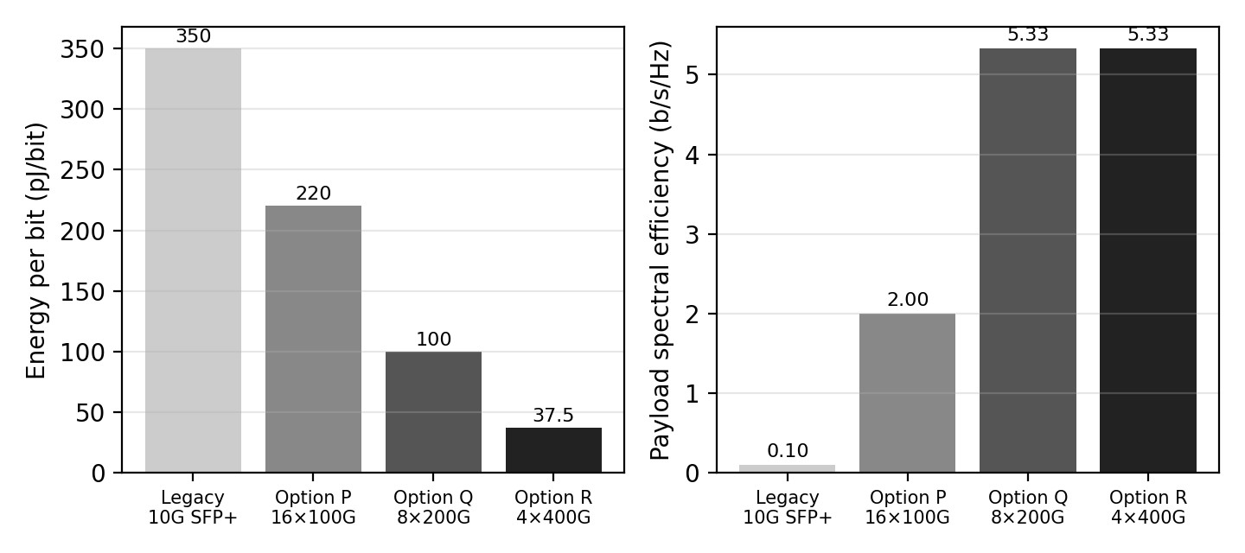
Figure 1 – Energy per bit and payload spectral efficiency of the options.

5.4 Sequence of repair, verification and upgrade
- Re-characterise with OTDR (100 ns bidirectional + 10 ns) and power meter to freeze the baseline.
- Repair events 3/4 (clean, then LC/APC fusion pigtails); re-test. This is the cheapest and largest gain (+0.70 dB).
- Re-fuse event 2 at the closure; re-test.
- Replace the Ch 5 transmitter and raise launch to +3 dBm; verify Q, ER, TJ, BER on the existing 10G system. This proves the fibre plant before new technology is added.
- Install Option R (4 × 400G) and retire the 10G channels to avoid cross-modulation between NRZ and coherent signals.
- Re-verify OTDR, OSA OSNR, pre-FEC BER, then a 24–72 h soak test.
Repairing before upgrading ensures that any later fault is attributable to the new equipment, not to the unresolved connector and splice, which would otherwise be hidden by FEC.

5.5 Ranking and selection
Criterion | Best | Middle | Worst
Spectrum (GHz) | Q = R (300) | – | P (800)
OSNR margin (dB) | P (34.5) | Q (27.5) | R (21.0), still ≥ 3 dB
Energy (pJ/bit) | R (37.5) | Q (100) | P (220)
Overall | R | Q | P

Selected: Option R. It ties Q for the lowest spectrum (300 GHz, leaving ~94 % of the C-band free), has the lowest energy (37.5 pJ/bit, −83 % vs P) and the fewest modules (4). Its 21 dB OSNR margin is the lowest but far above any practical requirement. A 75 GHz slot equals six 12.5 GHz slots on the G.694.1 flex grid. Total launched power is only +9 dBm at +3 dBm/channel, leaving room to raise per-channel power if the pluggable datasheet needs a higher receive power. Option Q is the fallback if more reach margin is later needed.
Measurements to repeat after the upgrade: bidirectional OTDR baseline; power-meter loss and per-channel power; OSA centre frequency (193.1 THz grid), OSNR at 0.1 nm; pre-FEC BER and
Q, post-FEC error-free operation; CD and PMD (DGD); module power draw; 24–72 h BER soak.

DESIGN DECISION 4 – Integrated optimization strategy
I recommend repair → verify on 10G → upgrade to Option R (4 × 400G Si-photonic, 75 GHz) → re-verify because the repaired link delivers a 3.65 dB margin and 47 dB OSNR (21 dB above the 26 dB need for 400G), PMD and dispersion are negligible, and Option R gives 1.6 Tb/s in 300 GHz (5.33 b/s/Hz) at 37.5 pJ/bit, which is 89 % less energy than the legacy module approach.

Stage 6 – Verification and Critical Evaluation
Requirement | Target | As-found | After repair / upgrade  (predicted)
Total optical link loss | ≤ 21.25 dB | 22.52 dB (+1.27) | 21.25 dB (events 2, 3 restored to 0.05 / 0.5 dB; ≈ 21.05 dB with 0.3 dB LC/APC)
Received optical power | ≥ −24 dBm  + 3 dB | −21.52 dBm; effective  −23.62 / −25.74 dBm | −18.25 dBm; effective −20.35 dBm (≥ −21 dBm)
System margin | ≥ 3 dB | Ch 3: 0.38 dB; Ch 5:  −1.74 dB | 3.65 dB both channels
OTDR event condition | No event above allowance | Ev 2: 0.62 dB; Ev 3: 1.20 dB, −22 dB | Ev 2 ≤ 0.1 dB; Ev 3 ≤ 0.5 dB, ≤  −60 dB; Ev 4 ≤ −50 dB
Eye / Q / jitter /  ER | Q ≥ 7.03; ER  ≥ 8.2 dB | Ch 3: Q 7.6, ER 9.0, TJ  0.349 UI; Ch 5: Q 4.7, ER  4.5, TJ 0.610 UI | Ch 5 ER ≥ 9 dB, Q ≥ 7.6 (≈ 16 at +3 dBm), TJ ≈ 0.35 UI
BER and quantum-limit gap | BER ≤ 10⁻¹² | Ch 3: 1.5 × 10⁻¹⁴; Ch 5:  1.3 × 10⁻⁶; gap 20.6 dB | BER  10⁻¹² on both channels; gap 20.6 dB (receiver) / 26 dB  (Rx power)
Upgrade spectrum and energy | 1.6 Tb/s, min pJ/bit | 80 Gb/s, 800 GHz, 350 pJ/bit | 1.6 Tb/s, 300 GHz, 5.33 b/s/Hz,  37.5 pJ/bit

Consistency check. (1) The budget margin for Ch 3 (0.38 dB) matches the Q-based margin (0.34 dB), so the loss accounting and the measured Q are consistent. (2) The two OTDR excess losses sum exactly to the 1.27 dB budget excess. (3) The ER swing ratio reproduces the measured Ch 5 Q.
(4) OSNR and PMD have large reserves, so the faults are loss and transmitter faults, as diagnosed. (5) All repair-stage values are predictions; they become evidence only after the post-repair measurements are logged, which is why the verification gate precedes the upgrade.
Final System Design

Workflow flowchart
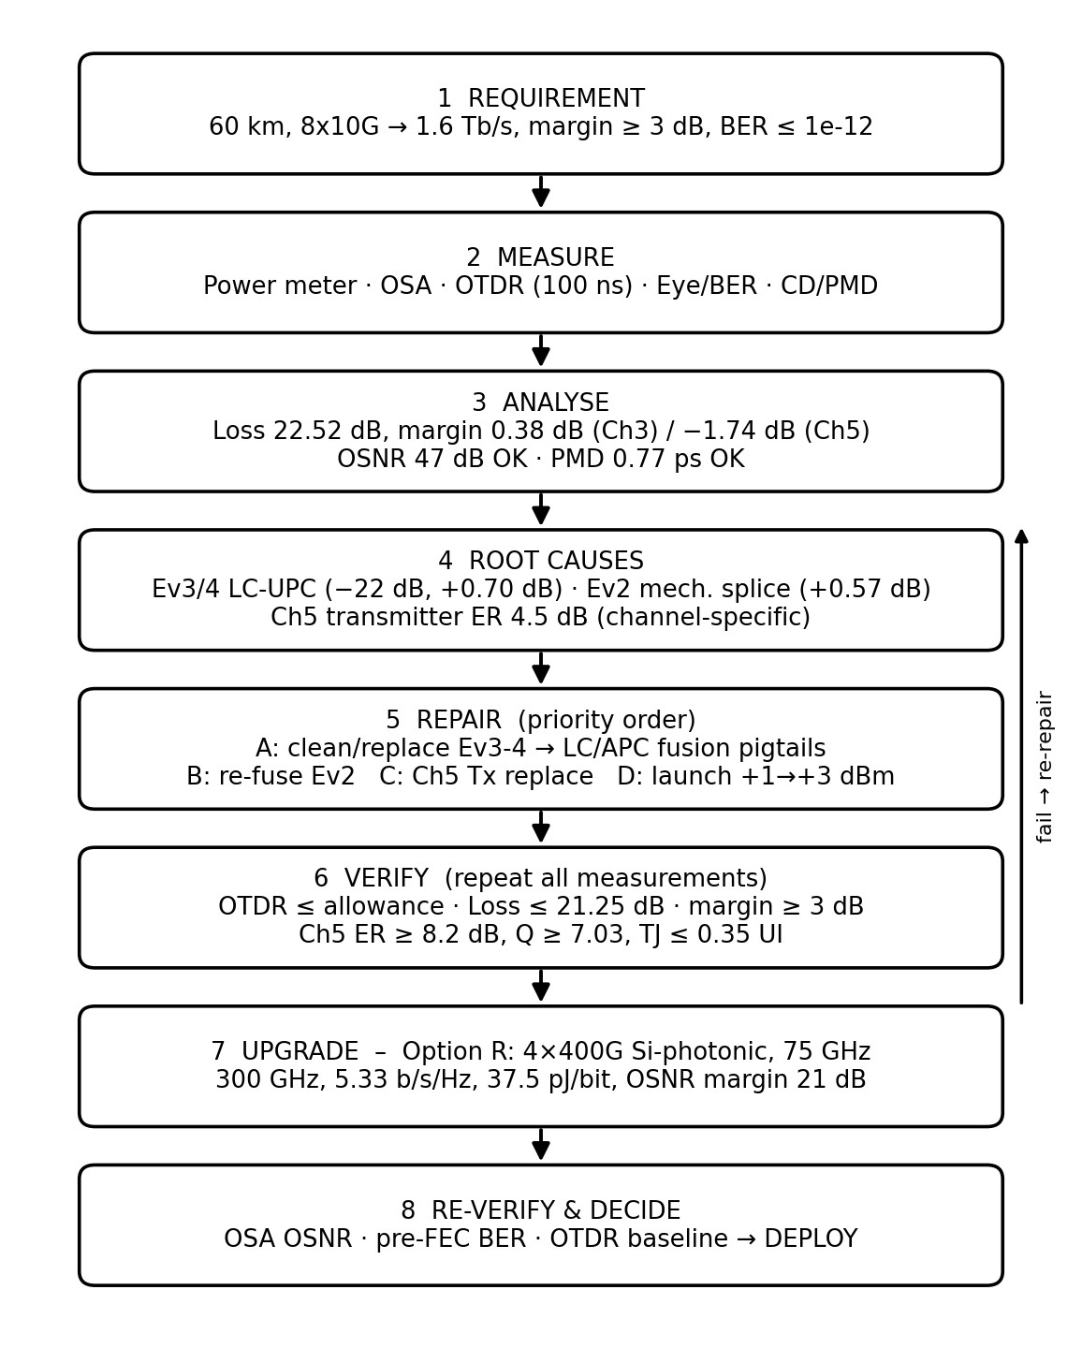
Figure 2 – Diagnostic, repair and upgrade workflow.
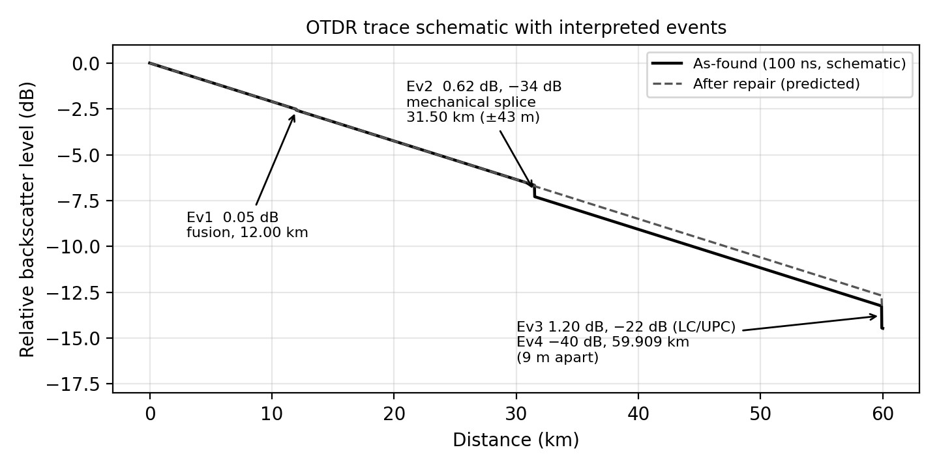
Figure 3 – Interpreted OTDR events, as-found versus predicted after repair (schematic). Final parameter and diagnostic table
Parameter | Value | Decision adopted
Fibre loss | 12.60 dB | No action
As-built / design loss | 22.52 / 21.25 dB | Repair to ≤ 21.25 dB
Dispersion penalty; PMD | 1.00 dB; 0.775 ps (≤ 10 ps) | No compensation needed
OSNR (booster) | 47 dB (need 20 dB) | Not limiting
Launch power | +1 dBm → +3 dBm/ch | Raise; verify nonlinearity
OTDR setting | 100 ns, bidirectional, launch/tail cables; 10 ns reverse shot | Adopted
Priority 1 / 2 | Event 3/4 connector / event 2 splice | LC/APC fusion pigtail / refuse
Ch 5 transmitter | ER 4.5 dB, Q 4.7, BER 1.3 ×  10⁻⁶ | Replace or re-bias; ER ≥ 9 dB
Quantum limit | −44.6 dBm direct; −48.0 homodyne; −45.0 heterodyne | Receiver 20.6 dB above limit
Selected upgrade | Option R, 4 × 400G, 75 GHz,  37.5 pJ/bit | 300 GHz, 21 dB OSNR margin
Ch n = +3 (50 GHz grid) | 193.25 THz, 1551.36 nm | G.694.1 compliant

Effect of each change (predicted)
Change | Why | Predicted effect
LC/APC pigtail at event 3/4 | +0.70 dB excess; −22 dB reflectance | Margin 0.38 → 1.08 dB; reflectance  ≤ −60 dB
Re-fuse event 2 | +0.57 dB excess; reflective mechanical splice | Margin → 1.65 dB
Launch +1 → +3 dBm | Penalties exceed repaired margin | Margin → 3.65 dB
Replace Ch 5 transmitter | ER 4.5 dB gives 2.12 dB extra penalty | Ch 5 margin 1.53 → 3.65 dB; Q 4.7  → ≥ 7.6; BER 1.3 × 10⁻⁶ → ≤ 10⁻¹⁴
Option R coherent upgrade | Capacity ×20 within  300 GHz | 1.6 Tb/s; 350 → 37.5 pJ/bit (−89 %)

Final Engineering Decision
- Budget and margin: repaired loss 21.25 dB; +3 dBm launch gives −18.25 dBm received, effective −20.35 dBm, margin 3.65 dB ≥ 3 dB. Excess loss (+1.27 dB) is traced entirely to events 2 and 3, with event 3 dominant.
- OTDR: 100 ns satisfies DR (27 ≥ 22.52 dB) and the EDZ (5 m < 9 m); the ADZ limit is handled with a 10 ns reverse shot. Priority is events 3/4, then 2; LC/APC and fusion splicing remove the reflective defects.
- Eye and BER: Ch 3 is healthy (Q 7.6, BER 1.5 × 10⁻¹⁴). Ch 5 failure is a transmitter ER fault (predicted Q 4.66 vs 4.7); replacing it restores Q ≥ 7.6 and TJ ≈ 0.35 UI.
- Quantum limit and coherent suitability: the receiver is 20.6 dB from the limit; coherent detection is shot-noise limited and received power is > 10 dB above the coherent limit, so ASE (47 dB OSNR, 21 dB margin for Option R) is the governing limit.
- Spectrum and energy: G.694.1 plan gives 1.6 Tb/s in 300 GHz (5.33 b/s/Hz) at 37.5 pJ/bit, 6× better than Option P and 9× better than the 10G modules.
Conditions and risk control. Deployment is released only if post-repair measurements show: loss ≤ 21.25 dB, every event within allowance, margin ≥ 3 dB, Ch 5 ER ≥ 8.2 dB with Q ≥ 7.03, and no nonlinear penalty at +3 dBm. If any gate fails, the contingency is: raise per-channel power further add a pre-amplifier or lower-loss demultiplexer, or fall back to Option Q (27.5 dB OSNR margin, same 300 GHz). These steps deliver 1.6 Tb/s on the existing fibre pair with no re-laying.

